Programming Paradigms

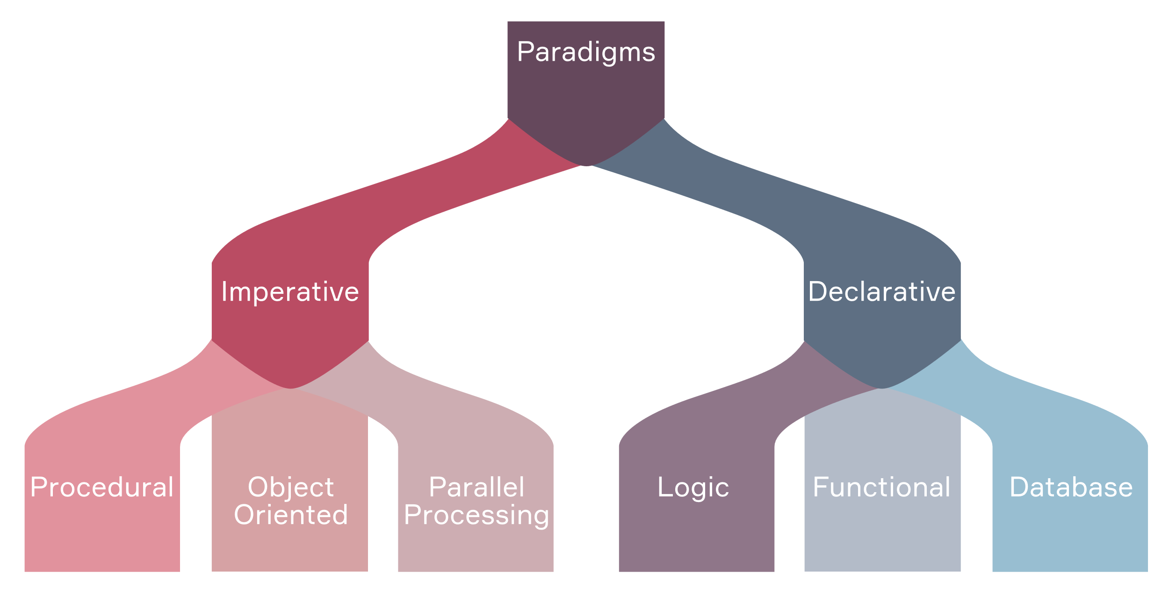

**Programming paradigms** is a way to solve problems using programming languages by using tools and techniques.

There are two approaches: Imperative Programming Paradigm, and Declarative Programming Paradigm.  
  
**1. Imperative Programming Paradigm:**

* *Focus on how to achieve a goal by changing the program’s state step-by-step.*

**-It includes:**

1. **Procedural Programming:** Procedural programming is like giving a computer a set of step-by-step instructions (called procedures or functions) to follow in order. It helps organize the code by breaking it into smaller parts, making it easier to understand and use again.

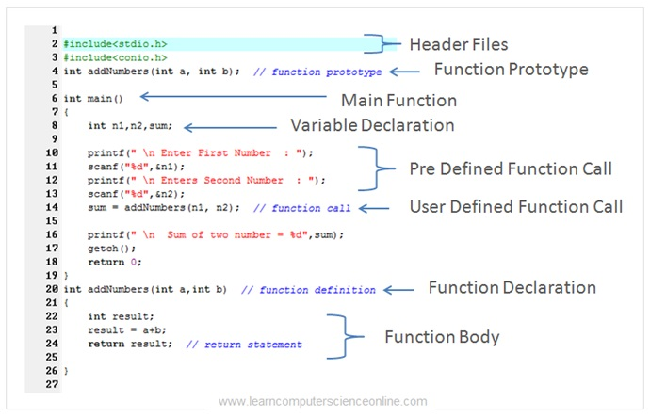

1. **Object-Oriented Programming (OOP):** OOP is a coding approach that organizes programs using classes and objects. It helps make code more structured, reusable, and easy to maintain by following four main principles: Encapsulation, Inheritance, Polymorphism, and Abstraction.

1. **Parallel Processing:** Runs multiple processes or threads at the same time to make programs faster and more efficient.

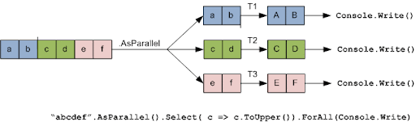

**2. Declarative Programming Paradigm**

* *Focus on what the outcome should be rather than detailing how to achieve it.* It avoids describing control flow and instead expresses the logic of computation.

**-It includes:**

1. **Logic Programming:** Logic programming is like teaching a computer to think like a detective. Instead of writing step-by-step instructions, you provide facts and rules, and the computer uses logical reasoning to find answers. It’s commonly used in AI and expert systems, where programs need to make decisions based on given knowledge.
2. **Functional Programming:** Functional programming treats programs like math equations—instead of modifying values, it evaluates functions and produces new results. It focuses on pure functions (no side effects), immutability, and higher-order functions, making it great for data processing and parallel computing.
3. **Database/Data-Driven Programming:** Database-driven programming is like building an app that reacts to stored data. Instead of hardcoding logic, applications query databases to determine what to do. This approach is essential for web applications and enterprise systems, where large amounts of data need to be processed dynamically.